Question:
Write a C++ program to implement Hamming Code for error detection and correction.
CODE:
include <iostream>

#include <string>

#include <algorithm>

using namespace std;

class hamming{

public:

string data; //it is the raw data received

int m , r = 0; // n is the length of raw data and r is the number of redundant bits

char * msg; // it will store the all bits (data + redundant). We made it dynamic because at compile time we dont know how much redundant bits will be there, we will initialize memory to it once we know the number of redundant bits.

hamming(string data){

this->data = data;

//reversing the data received

reverse(data.begin(),data.end());

m = data.size();

int power = 1;

//finding the number of redundant bits and storing them in r

while(power < (m + r + 1)){

r++;

power*=2;

}

//Allocating memory to our dynamic msg array(Note we are using one based indexing).

msg = new char[m+r+1];

int curr = 0;

//initializing the msg with data bits and for redundant bits, an initial value of n

for(int i = 1 ; i <= m+r ; i++){

if(i & (i-1)){

msg[i] = data[curr++];

}

else msg[i] = 'n';

}

//function call to set the redundant bits

setRedundantBits();

}

//function to show the whole msg

void showmsg(){

cout << "the data packet to be sent is : ";

for(int i = m+r ; i >= 1 ; i--){

cout << msg[i] << " ";

}

cout << endl;

}

void setRedundantBits(){

//for first redundant bit, check all those data bits at index where the first bit of index is set(1) similarly for second redundant bit, check all those data bits at index where the second bit of index is set(1), similarly for third redundant bit check all those data bits at index where the third bit of index is set to 1 and so on.

int bit = 0;

//outer loop runs for redundant bits (1 ,2 ,4 ,8 ....)

for(int i = 1 ; i <= m+r ; i*=2){

int count = 0;

//inner loop runs for data bits

for(int j = i+1 ; j<=m+r ; j++){

// checking if the data bit corresponds to our redundant bit or not using bit manipulation

if(j & (1 << bit)){

if(msg[j] == '1') count++; // counting the number of ones in corresponding data bits

}

}

//setting up redundant bits

if(count & 1) msg[i] = '1';

else msg[i] = '0';

//increasing the bit position.

bit++;

}

//showing up the message to be sent(data + redundant)

showmsg();

}

void receiver(){

//this ans will store the redundant bits, if they were right then according to even parity they will store 0 else if some error was made in a bit it will store 1

string ans = "";

int bit = 0;

//this loop corresponds to the logic used in set redundant bits function

for(int i = 1 ; i <= m+r ; i*=2){

int count = 0;

for(int j = i+1 ; j<=m+r ; j++){

if(j & (1 << bit)){

if(msg[j] == '1') count++;

}

}

//incrementing the ans variable with the parity of redundant bit

// if it was right then add 0 else 1

if(count & 1){

if(msg[i] == '1') ans.push_back('0');

else ans.push_back('1');

}

else{

if(msg[i]=='0') ans.push_back('0');

else ans.push_back('1');

}

bit++;

}

// if the ans had any occurrence of 1 then there is some fault

if(ans.find('1') != string::npos){

int power = 1;

int wrongbit = 0;

//evaluating the binary expression of ans variable

for(int i = 0 ; i < ans.size() ; i++){

if(ans[i]=='1') wrongbit+=power;

power*=2;

}

cout << "bit number " << wrongbit << " is wrong and having error " << endl;

}

// if the ans dont have any occurrence of 1 then it is correct

else{

cout << "correct data packet received " << endl;

}

}

};

int main(){

string data = "1011001";

hamming h(data);

// manipulating any ith data bit to check if receiver is detecting a error in that bit. If you eliminate the following line then correct code will be sent to receiver following that no error is received

//h.msg[i] == '0' ? h.msg[i] = '1' : h.msg[i] = '0';

h.receiver();

return 0;
v
O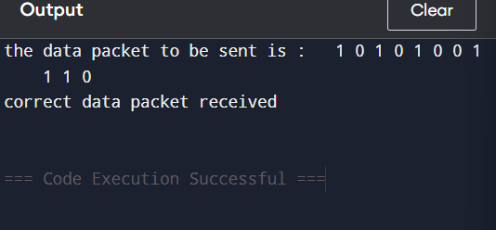UTPUT:

